First – this info should be moved to the wiki when we all have access. I’ll put the latest changes at the top of the so the older changes will drop to the bottom of the file.

2/14/14 Changes by Rob

* Debugging the system. Note that drive in telop mode works.
* Starting with the compressor
  + It is on relay channel 8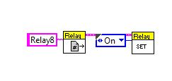
  + DIO Channel 14 was not changing. Need to determine which channel the compressor switch is connected to.
  + It appears that the switch is bad – the one on the compressor table looks OK.
    - Throw away the bad one
  + Had trouble getting the WPI compressor logic to run and couldn’t get my version of it running in the periodic task.
  + Created two copes of the Vis for turning on the compressor and place in the auto mode and teleop Vis. Should really fix this soon and create a VI for turning the compressor on and off.
* …
* …
* …

2/11/14 Changes by Rob

* Update Telop VI to use pilot joystick 1 for launching the catapult.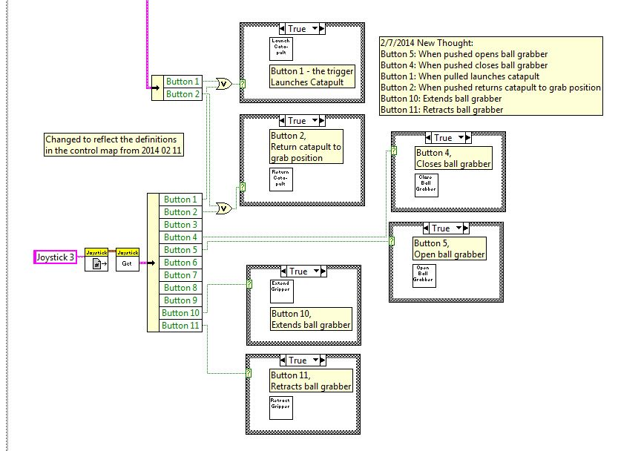
* …
* …

2/9/14 Changes made by Rob

* For the automode I’m pretty sure we can get away with the following commands:
  + Turn <degrees>
  + Move <distance>
  + GrabBall
  + ShootCatapult
  + …
* Zach started working on the auto mode and had questions …
* Zach made some changes to the SnoAutonomousMode VI
  + My one change: 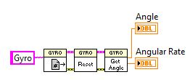
  + Zach’s change so far: 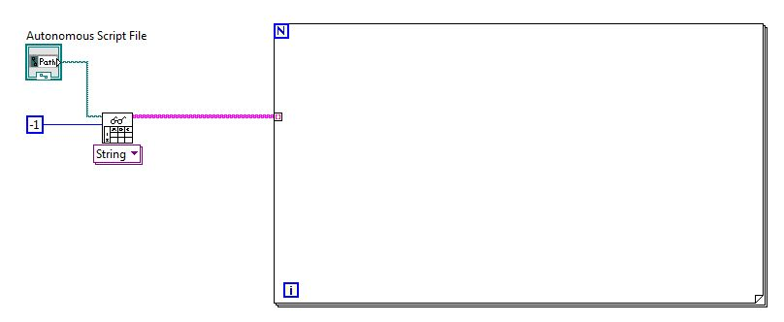
* My code from 2012 is in the BeachBot2012 project. The folder AutoCmdParsing has my VI is it: 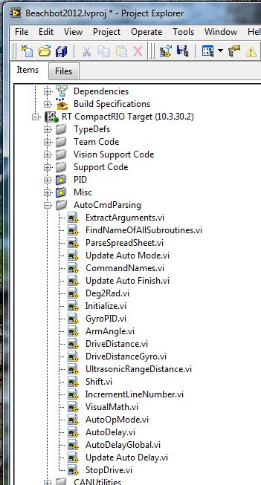
* My attempt at documenting what I was doing lives in the bb/2012/Programmming folder in the file file ‘AutonomousModeScripting.docx’.
* The file ‘AutonomousCommands.xlsx’ shows the format for the commands I implemented in 2012.
* Note that VI did not support .xlsx file and I converted everything to .csv files. You should be able to read the file using the VI ????
* The 2012 ParseSpreadSheet using the built in VI for reading the spread sheet: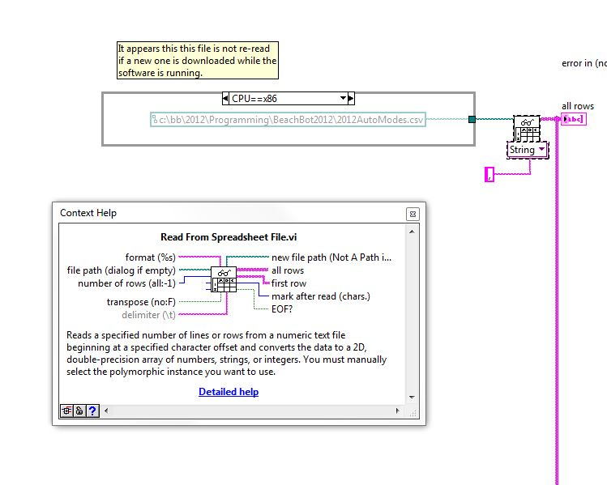
* …
* …

2/8/14 Changes made by Rob

* Changed the logic in the Begin VI to match the BB logic from previous years.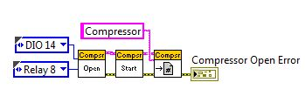
* Updated control map with new compressor signals.
* Updated the Periodic Task VI with the logic using the WPI Compressor Control Loop.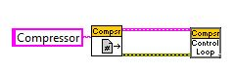
* …
* …
* …
* …
* …
* …
* …

2/7/14 Changes by Rob

* Changed name of the VI for launching the catapult to SnoLaunchesCatapult
* Added note to teleop VI on how buttons will work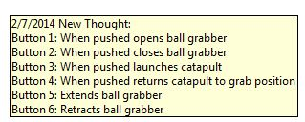
* Added Vis for ball grabber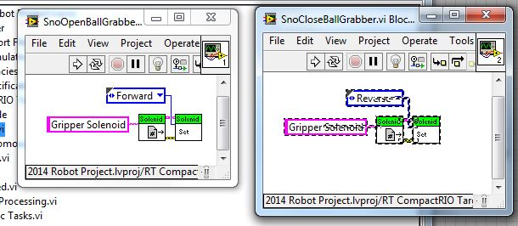
* For a feature that we might not need I’ve added the Vis for extending and retracting the gripper mechanism. 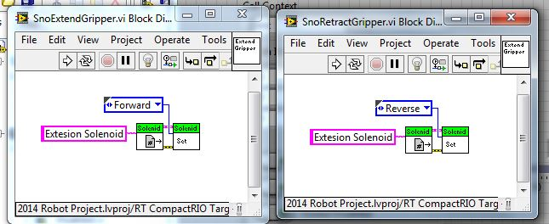
* Logic currently in place for the solenoids: 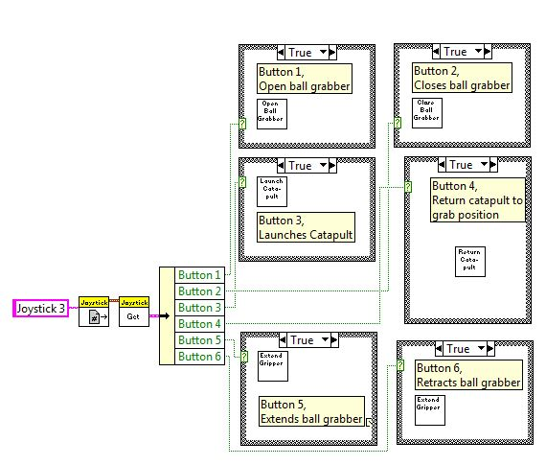
* Current explorer window: 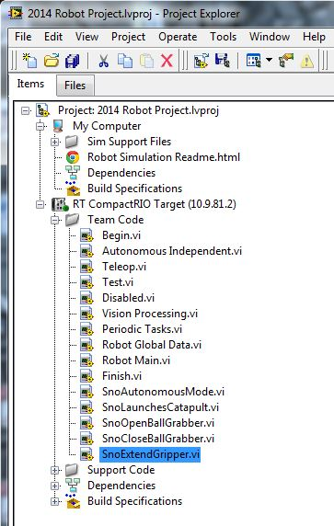
* Tried running on competition robot –
  + First issue – it was set for Java and an old image. I did the update from the Utilities option on the splash window.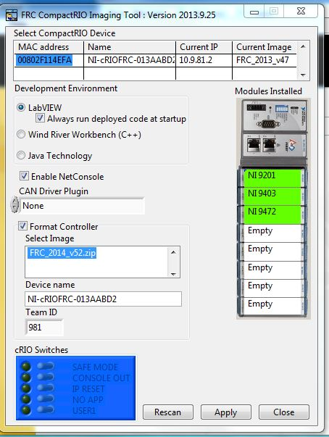
  + Here it shows the successful reimaging of the cRIO: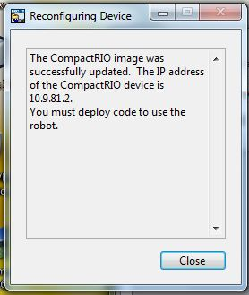
* Deployed current version as the default startup code.
* Just tried and deployment was successful.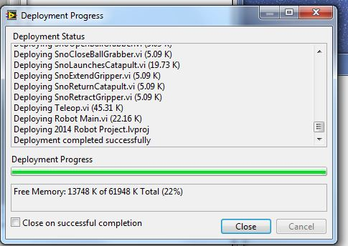
* Added Motor Value display to the front panel of the Teleop VI.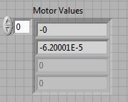
* …
* …
* …
* …

2/6/14 Changes by Rob

* Asked Zach to look into the parser. This is a low priority until the robot gets done.
* Changed solenoid control in Begin VI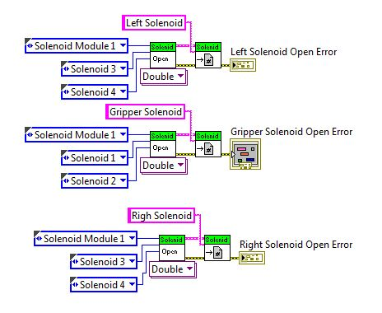
* Created VI for launching ball.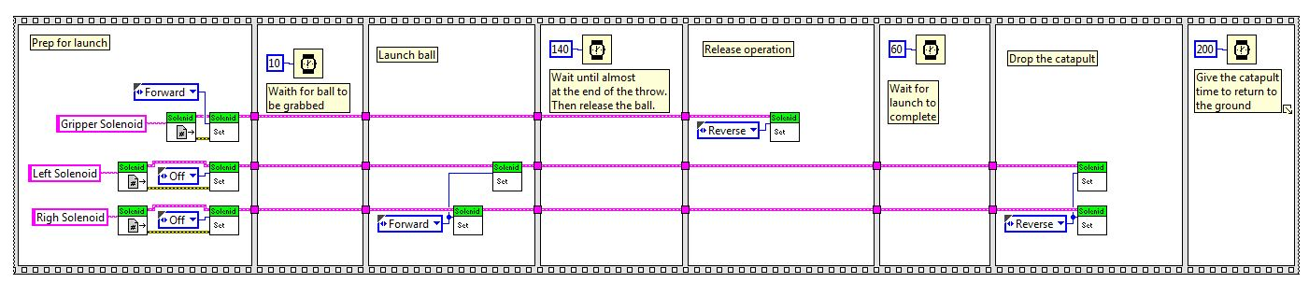
* Change the Begin VI to use two signals for controlling the two catapult cylinders instead of four signals.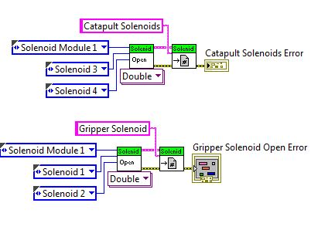
* New logic in the shooter based on the solenoid definition above.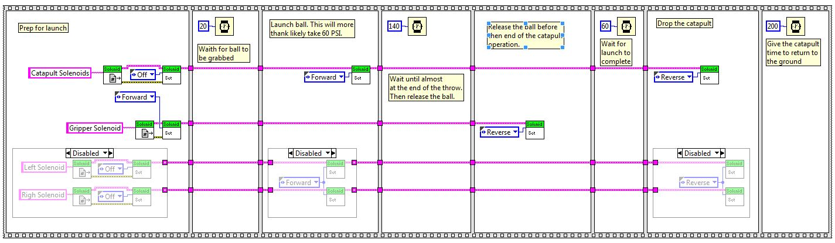
* …
* ….
* ….
* …
* …
* …

2/4/14 Changes by Rob

* Replaced missing VI with the WPI version of tank drive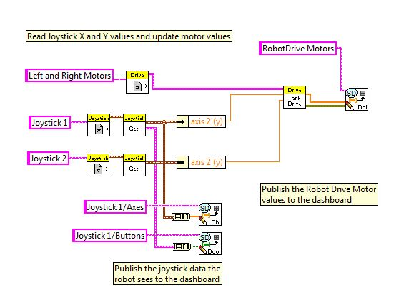
* Changed motors from Jaguar to Talon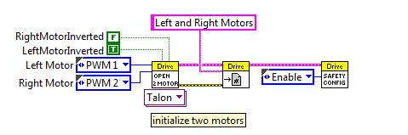
* Added 2nd joystick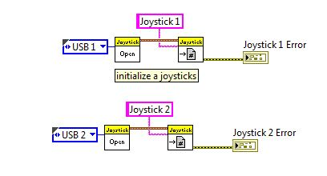
* Added compressor spike relay to Begin VI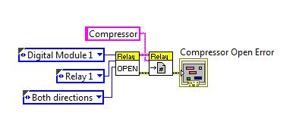
* Added compressor digital input to Begin VI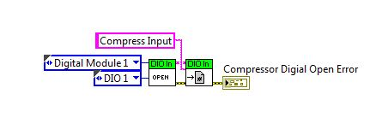
* Added condition enable block to the Begin VI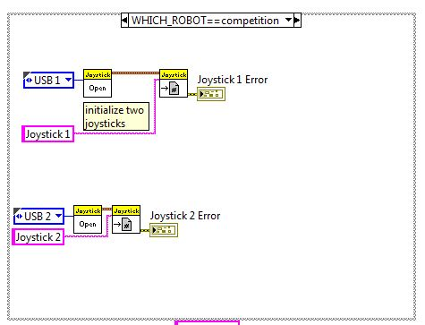
* Here is the simulator block, currently empty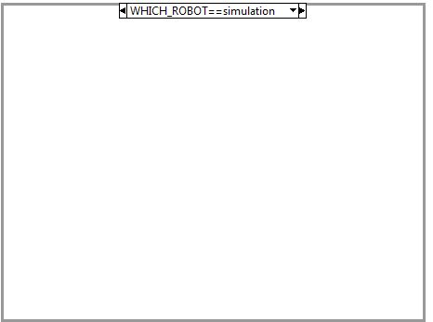
* Added logic for compressor to Periodic Task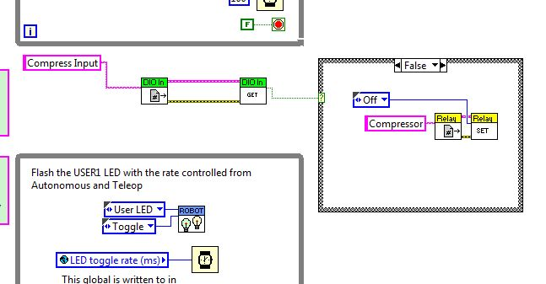
* Gyro open added to Begin VI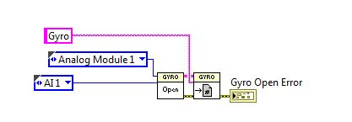
* Solenoid open logic added to Begin VI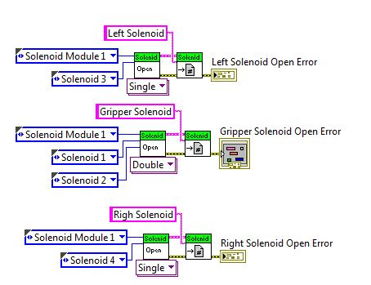
* This is the very start of the logic for grabbing and shooting. A lot more work and reading is necessary.